Productivity Funding Formula

Model Specifications – Year 5

Updated January 2021

Table of Contents

Overview…………………………………………………………………_____________________________________________ | 3
Summary of Measures………………………………………………… | 4
Metrics:
Credentials…………………………………………………….. | 7
Progression……………………………………………………. | 11
Transfer - 4-Year Universities………………..……………… | 15
Transfer - 2-Year Colleges………………..…………………. | 17
Gateway Course Success……………………………………. | 19
Credits at Completion………………………………………… | 23
Time to Degree………………………………………………... | 25
Research………………………………………………………. | 27
Diseconomies of Scale……………………………………….. | 29
Core Expense Ratio…………………………………………... | 30
Faculty to Administration Salary Ratio………………………. | 32
Scaling Calculations…………………...………………………. | 34
FAQs……………………………………………………………………. | 37
Contact Information…………………………………………………… | 39

Overview
Act 148 was enacted by the 91st General Assembly, and was signed into law by Governor Asa Hutchinson on February 8, 2017. The purpose of Act 148 of 2017 is to adopt a productivity-based funding model for state-supported institutions of higher education. Governor Hutchinson issued the following statement when he signed the bill into law:
“When I was elected Governor, I made it a goal for my administration to increase the percentage of Arkansans who attain post-secondary degrees from 40% to 60% by 2025. With the legislature’s passing of the new Productivity Funding Formula, we have taken an important step toward achieving that goal.
This new formula will be based upon student progress rather than student enrollment. This shift in focus will encourage and empower our students to successfully attain their degree, license or certificate in a timely manner. I am thrilled that the legislature has approved this measure, and I look forward to continued work with the Department of Higher Education and our state’s colleges and universities to make Arkansas a leader in student success.”
Source: Governor’s Press Release 02/08/2017

The Arkansas Department of Higher Education (ADHE) Productivity Funding Formula Model Technical Definitions:
The following pages provide detailed definitions for each category in the productivity funding model. These definitions outline a step-by-step process to generate the productivity data from the Arkansas Higher Education Information System (AHEIS) and other reports submitted to ADHE. For each metric there is a simplified definition, expanded definition, the required data tables and data elements, and a specific description of how the data will be generated. At the end of each metric description, a Points of Clarification section will provide additional information related to each metric.
Reference to frequently asked questions (FAQs) as well as agency contact information is located at the end of the document.

Summary of Measures
The productivity funding formula consists of four measures: Effectiveness, Affordability, Adjustments, and Efficiency. Each measure contains certain metrics:
Effectiveness | Affordability | Adjustment | Efficiency
- Credentials  - Progression  - Transfer Success  - Gateway Course Success | - Time to Degree  - Credits at Completion | - Research  (4-year only)  - Diseconomies of Scale (2-year only) | - Core Expense Ratio  - Faculty to Administrator Salary Ratio

The Post-Completion Success metric and Non-Credit Workforce Training and Education metric are not included in the formula but will be considered when adequate data is available. Other future model modifications, such as an addition of an inflationary index, will be considered when necessary.

In the formula, institutions receive points based on the requirements of each metric. Points are totaled and applied according to the weight of the metric. Once the points for the Effectiveness and Affordability measures are totaled, the Adjustments will be applied to the points accordingly. Finally, the Efficiency measure will be applied against the adjusted total. This final total of points will become the institution’s Productivity Index. That Productivity Index is compared to the prior year’s index for that institution. For example, for the Year 5 model run in 2021 the Productivity Index uses data averages from the Baseline subset of AY2017, AY2018, and AY2019 and compares it to the 3-year average from the Comparative subset of AY2018, AY2019, and AY2020. The difference in the Baseline Index and the Comparative Index is the Change in Productivity Index. This percent change determines the distribution of funding. For more information on how the distribution of funding will occur once the Change in Productivity Index is determined, please refer to the Funding Distribution Policy.

PRODUCTIVITY WEIGHTING
Each metric within the Productivity Funding Model has an assigned weight within the model as a whole. In 2019, changes to the Model were approved which created differences in the weightings between 4-Year Universities and 2-Year Colleges.

4 Year Universities

2 Year Colleges
Subset Types
Multiple categories of the formula use four years of institutional data. The first three years of the dataset are compared to the last three years of the dataset to determine productivity.
Baseline | Comparative
The average of the initial three years of the dataset. For the Year 5 Productivity model run baseline years include academic years 2017, 2018, and 2019. | The average of the last three years of the dataset. For the Year 3 Productivity model run comparative years include academic years 2018, 2019, and 2020.

Student Attribute Table
To simplify the Productivity calculation process, a student attribute table containing all relevant years of data has been created using various AHEIS table variables. Attribute table variables include:
Academic Year  Fice Code  School Abbreviation  Institution Type  SSN_ID  Graduate Student Flag | Student Name  Date of Birth  Age (25-54)  Black  Hispanic  Underserved Race | Underserved Income  Underserved Academic  Minimum Math Gateway Year Minimum Reading Gateway Year  Minimum English Gateway Year

Funding Model Definitions – Credentials
 | Simplified Definition:
 | In the Credentials metric institutions receive points for all credentials awarded, with special consideration for credentials earned by students who contribute to closing the attainment gap of underserved populations in Arkansas, as well as, credentials that meet state workforce needs.
 | Expanded Definition:
The model includes the number of credentials earned in all degree levels: Basic Certificates, Certificate of Proficiency, Technical Certificate, Associate Degree, Advanced Certificate, Bachelor’s Degree, Post-Bacc Certificate, Master’s Degree, Post-Master’s Certificate, Specialist, and Doctoral Degree.

Designated weights are applied to each level of credential. All credentials earned in STEM and High Demand fields receive additional weights.
 | Data Sources:
 | AHEIS Primary Data Files  Submitted by Institutions:  AHEIS Secondary Tables:  Support tables defined by the Ark Dept of Workforce Services (ADWS) & by ADHE with input from college and university administrators: |  |  | Student  Graduated Student  Course  Registration  Student Financial Aid  Fice Code  Degree Fice Year  STEM CIP Code  High Demand CIP Code
 | Specific Metric Criteria: Underserved Student Characteristics
 | Race/ethnicity  Data from Attribute Table  Race/ethnicity  (continued) | Student reported as either Hispanic or Black/African American by your institution.  Example: For AY2017, a student would be identified as underserved race/ethnicity if student was reported by your institution as either Hispanic or Black/African American for the academic year of the credential. If there is not a student record for that academic year, the previous academic year is reviewed. If there is still no student record, then the race reported in the graduated student table is used.  - When a student record is available in the attribute table, the race is used to set the attribute flag. The program does not continue to review prior year student data or graduated student file data.  - Non-resident aliens are excluded from receiving underserved student category points, however, the credentials they receive do receive points.  - The underserved race/ethnicity characteristic applies to both undergraduate and graduate credentials.
 | Income | Undergraduate student received a Pell Grant > $0 in at least one of the three most recent academic years at your institution.  Example: For credentials awarded in AY2017, the student would be identified as underserved income if student received a Pell Grant > $0 from your institution between AY2015 and AY2017.
 | Academic | Undergraduate student enrolled in at least one remedial course at your institution.  Example: For AY2017, the student would be identified as underserved academic if student previously enrolled in at least one remedial math OR English OR reading course at your institution.  - For a student to be identified as an underserved academic student, he or she would require previous registration in a remedial course. (Course level = ‘0’)  - Any remedial courses taken in high school prior to a student’s senior year are not reported to ADHE and will not be included.  - Grade received in the remedial course is not reviewed as it is assumed student successfully completed remedial course in order to progress and receive the credential.  - Remedial placement status in the student file is not used to identify student as underserved academic.
 | Age | Undergraduate student is between the ages 25 - 54 at initial enrollment at your institution. Age is calculated using the Graduated Student File Institution Admission Date YEAR and student’s reported date of birth to calculate age at initial entry to the institution at the undergraduate level.  - Age is recalculated if undergraduate student readmits after stop-out. If student stops-out and readmits several times the last readmit date is used to calculate age.  - Age is not calculated at time of the credential, but based on the initial enrollment date or readmit academic year.
 | Credential Types
 | STEM | Credential is in a STEM field identified by the four-digit CIP Code, and reported by the Immigrations and Customs Enforcement (ICE) agency. Additional CIP Codes approved by ADHE with input from institutional administrators are included in the AY2016 STEM list. The list will be reviewed every five years for possible updates. The AY2016 approved STEM CIP Code list used in the model will be reviewed for updates after the completion of Year 5 run of the model.
 | High Demand | Credential is in a High Demand field identified by the six- digit CIP Code, reported in the AY2016 AND AY2017 statewide High Demand Occupations Lists published by the Arkansas Department of Workforce Services (ADWS). The High Demand CIP Code Lists will be reviewed every five years for updates. This list will be reviewed for updates after the completion of Year 5 run of the model.
Operational Definitions:
The Credentials metric awards an institution points for the number of credentials awarded in all credential levels. The points differ between credential levels for 2-year and 4-year institutions.

The institution receives additional points from a multiplier for credentials listed on the STEM or High Demand CIP Code lists. For 4-year universities if the credential is both STEM and High Demand, the STEM designation would apply. For 2-year colleges the multiplier for STEM and High Demand is equal.

The institution receives additional points from a multiplier for credentials awarded to students meeting the underserved student criteria in race/ethnicity, income, academic, and age.

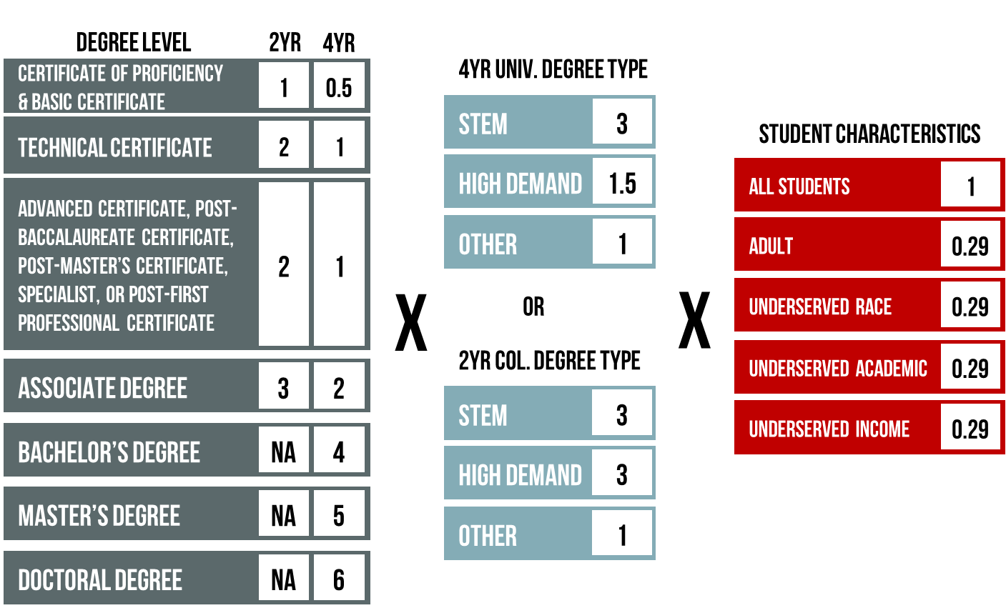
Baseline subset AYs  Comparative subset AYs |  |  | 2017, 2018, 2019  2018, 2019, 2020
The average of all earned points of the three-year baseline subset is compared to the average of the three-year comparative subset resulting in a percent change used in the formula calculation.
Points of Clarification:
- This metric counts credentials and not students receiving the credentials. If a student received more than one credential, they would receive points for all credentials received.

- In the Credentials metric, the only underserved student characteristic that uses the student attribute table is race/ethnicity.

- The STEM and High Demand CIP Codes will be updated to reflect changes made to CIP Codes by NCES with the release of the CIP 2020 list.

Funding Model Definitions – Progression
Simplified Definition:
In the Progression Metric institutions earn points as undergraduate students pass specific Progression goals.
Expanded Definition:
The model awards points to institutions based on the number of high school concurrent and undergraduate students who reach a progression goal during a given academic year. Progression points earned by underserved students in the areas of race/ethnicity, income, academic preparedness, and age will receive additional weight.
Data Sources:
AHEIS Primary Data Files  Submitted by Institutions:  AHEIS Secondary Tables: |  |  |  | Student  Registration / End-of-Term  Credit Course  Fice Code
Specific Metric Criteria: Underserved Student Characteristics
Race/ethnicity  Data from Attribute Table | Student reported as either Hispanic or Black/African American in the last term reported by your institution for each academic year OR in the last term reported by another institution(s) student attended when student earned credit hours that academic year that contributed to the total earned credit hours for that academic year.  Example: The student would be identified as underserved race/ethnicity:  If student was reported by your institution as either Hispanic or Black/African American in the last term reported for that academic year OR if student earned hours at another institution that reported their race as Hispanic or Black/African American in the last term reported for that student for that academic year.  - Non-resident aliens are excluded from receiving underserved student category points, however, they are included in the overall Progression metric and do receive points for passing progression goals.
Income  Data from Attribute Table | Student received a Pell Grant > $0 in at least one of the two most recent academic years at your institution OR at another institution student attended and earned credit hours that contributed to the total earned credit hours for that academic year.  Example: For AY2017, the student would be identified as underserved income if student received a Pell Grant > $0 in either AY2016 or AY2017 at your institution OR if same student received a Pell Grant > $0 in either AY2016 or AY2017 at another institution and earned hours at both institutions.
Academic  Data from Attribute Table | Student enrolled in at least one remedial course at your institution in this academic year OR student enrolled in at least one remedial course at another institution student attended and earned credit hours that contributed to the total earned credit hours for this AY.
Age | Undergraduate student is between the ages 24 - 54 on July 1st of that academic year AND 25 – 54 on June 30th of that academic year.  - Student must turn 25 during AY, but cannot turn 55 during AY.
Other Criteria:
Beginning AY |  | Total undergraduate student credit hours earned through AY2016 at all institutions.
Baseline subset AYs  Comparative subset AYs  End-of-term grades  2-Year Progression Goals  4-Year Progression Goals  AHEIS Course Levels  AHEIS Student Level |  | 2017, 2018, 2019  2018, 2019, 2020  Passing grades include: A, B, C, D, CR, S  15, 30 and 45 earned credit hours  15, 30, 45, 60 & 90 earned credit hours  1 – Lower level  2 – Upper level  00 - Unclassified undergraduate  01 - Freshman  02 - Sophomore  03 – Junior  04 – Senior  13 – High School Underclassman  14 – High School Senior
Operational Definitions:
Total undergraduate student credit hours earned through AY2016 from all institutions attended (including hours earned as a high school concurrent student) is totaled to begin the Progression calculation. Points are awarded based on the number of progression goals a student passed each year. This includes credit hours earned by the student at all institutions attended within the academic year.

- If the student earned 90 or more credit hours they are excluded from the
4-Year Progression metric. This eliminates Post-Bacc students from the Progression calculation.

- If a student earned 45 or more hours they are excluded from the 2-Year Progression metric.

- If a student reaches a progression goal and is enrolled at more than one institution that academic year, each institution that contributed to the progression goal will receive the credit.

Example:
A student attending a 4-year university on July 1, 2017 had accumulated 32 earned credit hours. On June 30, 2018, the student had accumulated 65 earned credit hours. During this academic year, the student took 6 hours at a 2-year college. The 4-year university will earn two progression points for the student passing the 45 and 60-hour progression goals. The 2-year college will receive one progression point for the student passing the 45-hour progression goal.

The chart below indicates the progression points available for both 2-year colleges and 4-year universities.

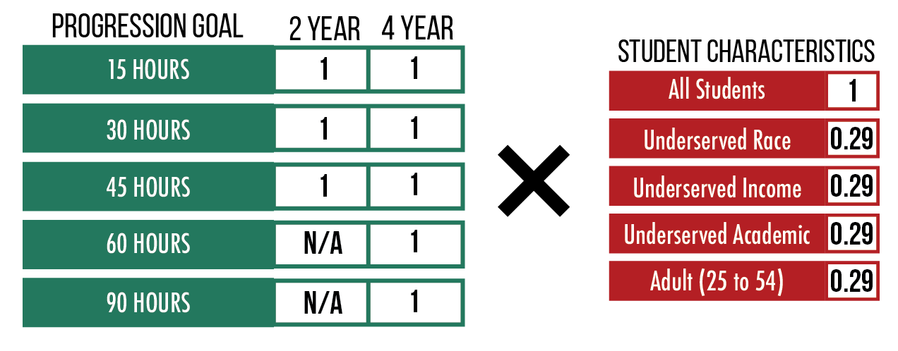

Baseline subset AYs  Comparative subset AYs |  |  | 2017, 2018, 2019  2018, 2019, 2020
The average of all earned points of the three-year baseline subset is compared to the average of the three-year comparative subset resulting in a percent change used in the formula calculation.
Points of Clarification:
- The Progression metric involves cross referencing AHEIS data from all public institutions in the state. Because of this cross referencing this is not a metric an institution can reproduce on its own. The data from outside institutions will be provided in the metric files when run by ADHE for internal checks.

- If the student is identified as an underserved population at any institution at which that student attended for that academic year, the student will be considered underserved for this metric.

- It is important all Incomplete (I), In Progress (IP), and Not Reported (NR) grades be reconciled in the End-of-Term submission for an institution to receive all deserved progression points.

Transfer Metric – 4-Year Universities

Simplified Definition:
The Transfer metric encourages collaboration between 2-year colleges and 4-year universities to promote student success.
Expanded Definition:
4-year universities will earn points for undergraduate students who have successfully transferred from a 2-year college and who earn a Bachelor's degree.
AHEIS Data Sources:
AHEIS Primary Data Files  Submitted by Institutions:  AHEIS Secondary Table: |  | Graduated Student  Student  Fice Code
Specific Metric Criteria:
AHEIS Credential Academic Years  AHEIS Credential Degree Level  AHEIS Enrollment Status  AHEIS Institution Type |  | 2017, 2018, 2019, 2020  05 – Bachelor’s Degree  03 – First-Time Entering Undergraduate Transfer at 4-Year University  2 – Two-Year College
Operational Definitions:
4-year universities receive points for undergraduate students who graduate with a Bachelor's degree who meet the following criteria:

- 4-Year university reported student as earning a Bachelor’s Degree in AY2017, AY2018, AY2019, AY2020

- Student attended an Arkansas public 2-year college

- Student transferred to 4-year university within three years of last attendance at the 2-year college

Baseline subset AYs  Comparative subset AYs | 2017, 2018, 2019  2018, 2019, 2020
The average of all earned points of the three-year baseline subset is compared to the average of the three-year comparative subset resulting in a percent change used in the formula calculation.
Points of Clarification:
- The Transfer Metric only looks at transfers from an in-state, public, 2-year college to an in-state, public, 4-year university.

Transfer Metric – 2-Year Colleges

Simplified Definition:
The Transfer metric encourages collaboration between Arkansas 2-year colleges and 4-year public and private/independent universities to promote student success.
Expanded Definition:
2-year colleges earn points for undergraduate students who transfer successfully to a
4-year university with an Associate degree or with at least 30 earned ACTS course hours. Students who have received an Associate degree will be weighted more heavily.
AHEIS Data Sources:
AHEIS Primary Data Files  Submitted by Institutions:  AHEIS Secondary Tables: |  | Student  Registration  Credit Course  Graduated Student  ACTS Course  Fice Code
Specific Metric Criteria: 2-Year Associate Degree Transfer Metric
AHEIS Degree Level  AHEIS AY of Transfer to 4-Year  AHEIS Institution Type  AHEIS Enrollment Status |  | 03 – Associate Degree  2017, 2018, 2019, 2020  4-Year Public or Private/Independent Universities  03 – First-Time Entering Undergraduate Transfer at 4-Year University
Specific Metric Criteria: 2-Year 30 + ACTS Hours Transfer Metric
Total ACTS Course Hours  AHEIS Course Levels  AHEIS Institution Type  AHEIS Enrollment Status |  | > or = 30 Credit Hours  1 – Lower level  2 – Upper level  4-Year Public or Private/Independent Universities  03 – First-Time Entering Undergraduate Transfer at 4-Year University
Operational Definition:
2-Year College Associate Degree Transfer Metric:
2-year colleges receive points for students who graduate from their college with an Associate degree and enroll as a transfer student at an Arkansas 4-year public university OR a 4-year Arkansas private/independent, not-for-profit institution within three years after completing the Associate degree.

2-Year College 30 or More ACTS Credit Hours Transfer Metric:
2-year colleges receive points for students who have earned 30 or more ACTS credit hours with a grade of A, B, C, D, CR, or S and then enroll as a transfer student at a 4-year public university OR a 4-year Arkansas private/independent, not-for-profit institution within three academic years of their last enrollment at the 2-year college. Institutions will not receive points in the 30(+) ACTS Hours metric for students who have already earned an Associate degree.

Baseline subset AYs  Comparative subset AYs | 2017, 2018, 2019  2018, 2019, 2020
The average of all earned points of the three-year baseline subset is compared to the average of the three-year comparative subset resulting in a percent change used in the formula calculation.
Points of Clarification:
- The Transfer Metric only looks at transfers from an in-state, public, 2-year college to an in-state, 4-year public OR private/independent university.

- Institutions will not receive points in the 30(+) ACTS Hours metric for students who have already earned an Associate degree.

Gateway Course Success Metric
Simplified Definition:
Completion of gateway courses contributes to student progression and degree attainment.
Expanded Definition:
Institutions earn points for students completing math, English and reading gateway courses with an earned grade of A, B, C, S, or CR. Each student receives credit for passing one course per gateway subject. Academically underserved students will be weighted more heavily.
Data Sources:
AHEIS Primary Data Files  Submitted by Institutions:  AHEIS Secondary Tables: |  |  | Student  Registration / End-of-Term  Credit Course  Fice Code
Specific Metric Criteria:
Academic Year  Math Gateway  Math Gateway with Remediation  English Gateway  English Gateway with Remediation  Reading Gateway  Reading Gateway with Remediation  AHEIS Enrollment Status |  |  | 2017, 2018, 2019, 2020  Student passed Math Gateway  Student passed Math Gateway and  required Math remediation  Student passed English Gateway  Student passed English Gateway and required English remediation  Student passed Reading Gateway  Student passed Reading Gateway and required Reading remediation  2-Year – All  4-Year – Undergraduates excluding high school students
Operational Definition:
This metric awards points to institutions for students who earn a grade of A, B, C, S, or CR in an approved Arkansas Course Transfer System (ACTS) general education course in math, English and reading, or ADHE approved terminal subject area course.

The ACTS Course name and number of the approved gateway courses are listed in the table below. Each institution will receive additional points for a student who is identified as academically underserved by registration in a remedial course in Math, English or Reading within the last five years prior to the successful completion of the gateway course in that subject. For example, if student completed their first Math Gateway course in AY2017, the institution would receive additional points if student took remedial math anytime between AY2012 and AY2017.

The institution will earn points for the student’s completion of the first gateway course in each subject area. For example, if student completed their first Math Gateway course in AY2017, the institution would receive a point, however, if the same student completed another Math Gateway course in AY2018 the institution would not receive a point since the student had already passed a Math Gateway course in AY2017.

A list of approved course exceptions which have been added to the Approved Gateway Course List for specific institutions may be provided upon request.

Gateway Course Subject Area | ACTS Course Name |  |  | Approved ACTS Course Number
Math | College Math |  |  | MATH1003
 | Quantitative Literacy |  |  | MATH1113
 | College Algebra |  |  | MATH1103
 | Plane Trigonometry |  |  | MATH1203
 | Pre-Calculus |  |  | MATH1305
 | Introduction to Statistics |  |  | MATH2103
 | Survey of Calculus |  |  | MATH2203
 | Calculus I |  |  | MATH2405
 | Calculus II |  |  | MATH2505
 | Calculus III |  |  | MATH2603
English | Composition I |  |  | ENGL1013
 | Composition II |  |  | ENGL1023
 | Technical Writing |  |  | ENGL2023
Reading | Introduction to Anthropology |  |  | ANTH1013
 | Cultural Anthropology |  |  | ANTH2013
 | World Literature I |  |  | ENGL2113
 | World Literature II |  |  | ENGL2123
 | Western Literature I |  |  | ENGL2213
 | Western Literature II |  |  | ENGL2223
 | American Literature I |  |  | ENGL2653
 | American Literature II |  |  | ENGL2663
 | British Literature I |  |  | ENGL2673
 | British Literature II |  |  | ENGL2683
 | World Civilizations I |  |  | HIST1113
 | World Civilizations II |  |  | HIST1123
 | Western Civilizations I |  |  | HIST1213
 | Western Civilizations II |  |  | HIST1223
 | United States History I |  |  | HIST2113
 | United States History II |  |  | HIST2123
 | Philosophy |  |  | PHIL1103
 | American National Government |  |  | PLSC2003
 | State and Local Government |  |  | PLSC2103
 | General Psychology |  |  | PSYC1103
 | Developmental Psychology |  |  | PSYC2103
 | Introduction to Sociology |  |  | SOCI1013
 | Social Problems |  |  | SOCI2013
A student receives credit for the completion of one course per gateway subject at each institution. For example, a student completes U.S. History I and General Psychology at the same institution. Student will receive one point for completing the reading gateway course requirement. The exception to this is if gateway courses are taken at separate institutions. For example, a student takes Composition I at Institution A and then transfers to Institution B where he/she takes Composition II. Both institutions will receive one point for the student completing an English gateway course at that institution.

A crosswalk of the above listed ACTS gateway courses with course names and numbers can be found on the ADHE ACTS website.

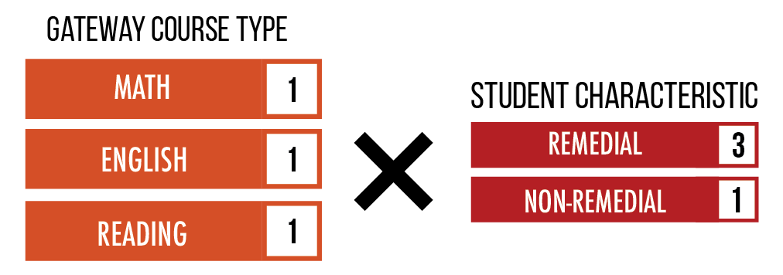
Baseline subset AYs  Comparative subset AYs |  | 2017, 2018, 2019  2018, 2019, 2020
The average of all earned points of the three-year baseline subset is compared to the average of the three-year comparative subset resulting in a percent change used in the formula calculation.
Points of Clarification:
- In this metric the underserved academic category is broken down by math, English, and reading subjects rather than just being any remediation as used in previous metrics. The institution receives additional points if the student required discipline specific remediation to support completing the gateway course.

- Any remedial courses taken in high school prior to a student’s senior year are not reported to ADHE and will not be included in the calculation of underserved academic.

- In the Gateway Course Success Metric, 2-Year colleges receive credit for all students.

- 4-year universities receive credit for undergraduate students, excluding high school students.

Credits at Completion Metric
Simplified Definition:
An average of the number of students who graduated within the scheduled number of credits completed for Bachelor’s and Associate degrees over the most recent three academic years.
Expanded Definition:
The model awards points for students who graduate on schedule. On schedule is defined as completing a Bachelor’s degree with 120 credit hours or completing an Associate degree with 60 credit hours. Remedial level coursework as defined by AHEIS is not calculated into the total number of hours a student completed for this metric. Institutions are also given points for students who complete on schedule + 10% or on schedule + 25%. Only Associate degrees and Bachelor’s degrees will be measured.
Data Sources:
AHEIS Primary Data Files  Submitted by Institutions:  AHEIS Secondary Table: |  | Graduated Student  Registration  Credit Course  Fice Code
Specific Metric Criteria:
Academic Years  Degree Levels  Total Earned Credit Hours  Completed On Schedule  Completed On Schedule +10%  Completed On Schedule +25% |  | 2017, 2018, 2019, 2020  Associate and Bachelor’s Degrees  Completed in 60 or 120 hours  Completed in 61-66 hours or 121-132 hours  Completed in 67-75 hours or 133-150 hours
Operational Definition:
For each Associate degree and Bachelor’s degree awarded, the student’s total credit hours earned from all in-state, public institutions will be calculated. Remedial level coursework will be excluded from this total. The total credit hours will be divided by the standard required program credits, 60 hours for Associate degree and 120 hours for Bachelor’s degree, per AR Code 6-61-232 (2012). That percentage will result in that degree being added to one of three categories: on schedule, on schedule + 10%, and on schedule + 25%. Degrees completed on schedule will result in a full point, whereas degrees completed on schedule + 10% or + 25% will receive a reduced point. Degrees completed with more than 125% of legislated credit needed for that degree will not receive credit in this metric.
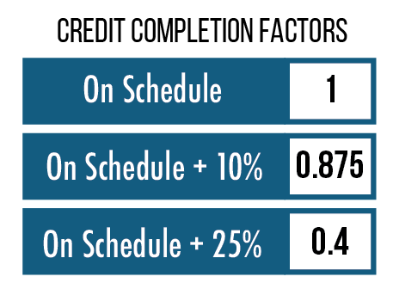
Baseline subset AYs  Comparative subset AYs | 2017, 2018, 2019  2018, 2019, 2020
The average of all earned points of the three-year baseline subset is compared to the average of the three-year comparative subset resulting in a percent change used in the formula calculation.
Points of Clarification:
- A list of approved exceptions for the Credits at Completion metric is available upon request. CIP Codes may be approved for extended time in this metric if the external accrediting body for that credential requires an extended time to complete the credential beyond the state legislated 60 hours, two-year standard time. For example, AAS in Registered Nursing requires additional hours above the normalized 60 credit hours for an Associate degree by their accrediting body. To request an exception be approved for a degree, institutions may contact the ADHE Academics division.

Time to Degree Metric
Simplified Definition:
An average of the number of students who graduated within the recommended timeframe for Associate and Bachelor’s degrees over the most recent three academic years.
Expanded Definition:
Institutions are assigned a score based on the number of students that graduate on time. On time is defined as 24 months for Associate degrees and 48 months for Bachelor’s degrees. Points will also be garnered for students who complete their degree on time + 25% (30 months; 60 months) or on time + 50% (36 months; 72 months). Only Associate degrees and Bachelor’s degrees will be measured. Other certificates and degrees will not be counted in this metric
Data Sources:
AHEIS Primary Tables:  AHEIS Secondary Tables: |  | Graduated Student  Student  Fice Code
Specific Metric Criteria:
Academic Years  Degree Levels  Initial Admit Date  Graduation Date  Time to Degree in Months  Completed On Time  Completed On Time + 25%  Completed On Time + 50% |  | 2017, 2018, 2019, 2020  Associate and Bachelor’s Degrees  Student’s Initial Admit Date to Institution  Graduation Date  Calculated using Initial Admit Date and Graduation Date  Completed in 24 months or 48 months  Completed in 25-30 months or 49-60 months  Completed in 31-36 months or 61-72 months
Operational Definition:
Only students who entered the institution as a first-time, full-time, degree-seeking undergraduate student (traditionally thought of as the IPEDS cohort) will be included in the cohort for this metric. For each Associate and Bachelor’s degree awarded, the total number of months the student took to complete their degree at that institution will be measured.
That total number of months will be divided by the standard number of months required for students to complete their degree on time (24 months for an Associate degree; 48 months for a Bachelor’s degree). That percentage will result in that degree being added to one of three categories: on time, on time + 25%, and on time + 50%.

Degrees completed on time will result in one point; degrees completed on time + 25% or + 50% will received a reduced point.
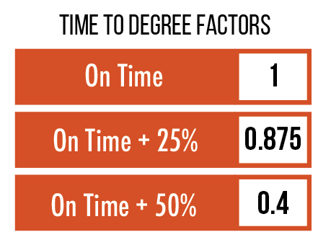
Baseline subset AYs  Comparative subset AYs | 2017, 2018, 2019  2018, 2019, 2020
The average of all earned points of the three-year baseline subset is compared to the average of the three-year comparative subset resulting in a percent change used in the formula calculation.
Points of Clarification:
- Time to Degree is the only metric that uses the traditional IPEDS cohort definition of First-time, Full-time, Degree Seeking.

- For degree programs with approved exceptions to the total number of credits at completions the time to degree months will be adjusted to reflect the additional hours required for completion.

Research Adjustment – 4-Year Universities
Simplified Definition:
Research is essential to the discovery of new knowledge, innovation, entrepreneurism, and societal, health, and economic development advancements. One unique mission of some public universities that is not adequately captured in productivity measures is research and should be included as an adjustment to appropriate institutions.
Expanded Definition:
This metric increases the comparative years score of institutions who invest in research by a percentage based on the ratio of research expenditures to total expenditures of the institution as reported to IPEDS. This applies only to institutions who report research expenditures to IPEDS.
Data Sources: IPEDS Finance Survey
Specific Metric Criteria:
IPEDS Finance Survey Data: | Institution Name  State Abbreviation  Sector of Institution  Research  Total Expenses Deductions
Operational Definition:
The adjustment for each institution is calculated by finding the percentage of research expenditures to total institutional expenditures as reported on most recently published IPEDS. A 3-year average of the Research expenditures will be used to calculate a research percentage. The resulting percentage is multiplied by the comparative year index score to determine the adjustment.
Points of Clarification:
- Applies to 4-year universities with research expenditures only.

- Due to the one year delay in the publishing of IPEDS data, the score calculated in this metric will always be one year prior to other data used in the formula.

- In 2019, policy was changed on how the Research Adjustment is calculated. This adjustment is now applied only to the comparative years score and does not apply to the baseline score of the model.

Diseconomies of Scale Adjustment
2-Year Colleges
Simplified Definition:
Adds a percentage increase to the scores of 2-year colleges serving a small population of students.
Expanded Definition:
This adjustment is to recognize that institutions must maintain certain student services regardless of the institution's student enrollment size. This metric increases the index score of a 2-year college that falls into a specified student enrollment size range. The range is based on average three-year enrollment for all 2-year colleges.
Data Sources:
AHEIS Primary Table: | Student
Specific Metric Criteria:
Annual unduplicated headcount not including high school students

Academic Years: 2018, 2019, 2020
Operational Definition:
The score for each institution is calculated by finding the average enrollment for 2-year colleges as the baseline for comparison. The institution’s enrollment will be calculated by averaging the annual unduplicated headcount of students NOT including high school/concurrent (enroll_status=13) for the most recent three academic years. This adjustment is applied to the comparative years total only.
Points of Clarification:
- Applies to 2-year colleges only.
- In 2019, policy was changed on how the Diseconomies of Scale Adjustment is calculated. This adjustment is now applied only to the comparative years score and does not apply to the baseline score of the model.
Core Expense Ratio
Simplified Definition:
Measures the core expense ratio of each institution as compared to its SREB peer group.
Expanded Definition:
Core Expense Ratio is equal to the sum of Instruction Expenditures, Academic Support Expenditures, Student Services Expenditures, Public Service Expenditures and Research Expenditures (all per FTE) divided by the Institutional Support Expenditures per FTE.
Data Source: IPEDS Finance Survey
Specific Metric Criteria:
Institution (entity) Name
State Abbreviation
Sector of Institution
Instruction
Research
Public Service
Academic Support
Student Services
Institutional Support
12-Month Full-time Equivalent Enrollment
Carnegie Classification 2015: Graduate Instructional Program (4-Year Universities)
Carnegie Classification 2015: Basic (2-Year Colleges)
Operational Definition:
The Core Expense Ratio will look at the most recent three years of published IPEDS data. Because it will use published IPEDS data the years of data used will always be one year prior to other data used in the formula. The Core Expense Ratio is calculated by taking the sum of IPEDS reported Instruction Expenditures, Academic Support Expenditures, Student Services Expenditures, Public Service Expenditures and Research Expenditures (all per FTE) divided by the Institutional Support Expenditures per FTE. This ratio will be calculated for each of the most recent three years and then will be averaged.

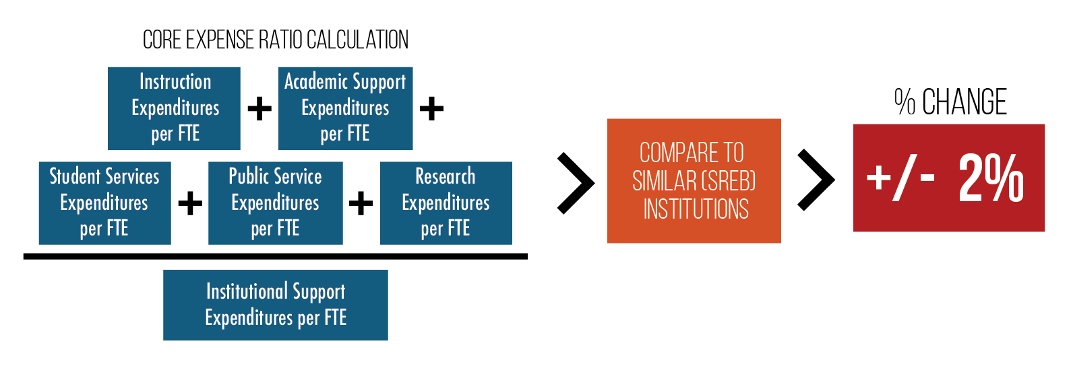
The baseline group that the institutional Core Expense Ratio will be compared to is the institution’s SREB peer group. The SREB peer group will be defined as all SREB institutions outside of the state of Arkansas who are in the same Carnegie Classification as the institution who report FTE data to SREB. A three-year Core Expense Ratio Average will be calculated for the SREB peer group in the same way that it was calculated for the institution.

The adjustment for each institution is calculated by finding the percentage deviation of the Core Expense Ratio of each institution compared to the SREB Average Core Expense Ratio for their peer group. The resulting percentage is assigned an effectiveness adjustment as described in the chart below.
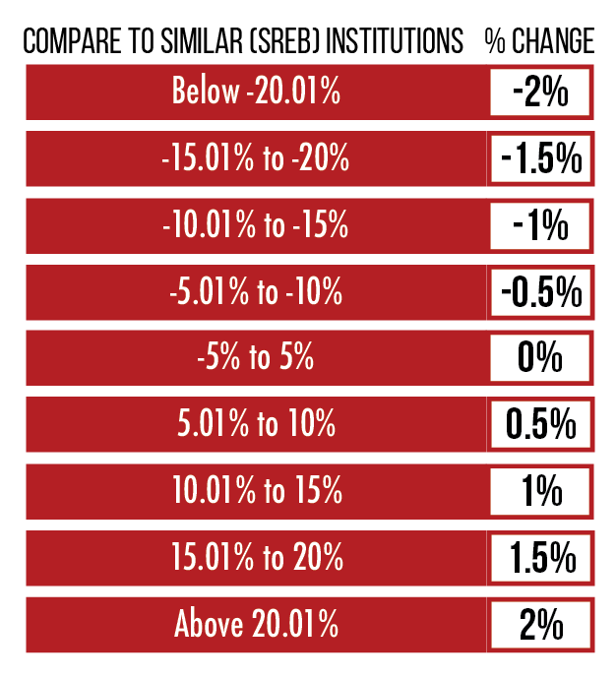
Points of Clarification:
- This metric is 50% of the Efficiency Category. The Efficiency Category can influence an institution’s score by no more than +/- 2%.

- A list of institutions included in the SREB peer group will be provided to each institution.
Faculty to Administrative Salary Ratio
Simplified Definition:
Measures the ratio of faculty salaries to administrative salaries at an institution as compared to its SREB peer group.
Expanded Definition:
Faculty to Administrative Salary Ratio is equal to the Instruction Salaries & Wages per FTE divided by the Institutional Support Salaries & Wages per FTE.
Data Source: IPEDS Finance Survey
Specific Metric Criteria:
Institution (entity) Name
State Abbreviation
Sector of Institution
Instruction – Salaries and Wages
Institutional Support – Salaries and Wages
12-Month Full-time Equivalent Enrollment
Carnegie Classification 2015: Graduate Instructional Program (4-Year Universities)
Carnegie Classification 2015: Basic (2-Year Colleges)
Operational Definition:
The Faculty to Administrative Salary ratio will look at the most recent three years of published IPEDS data. Because it will use published IPEDS data the years of data used will always be one year prior to other data used in the formula. The Faculty to Administrative Salary ratio is calculated by taking the Instruction Salaries & Wages per FTE divided by the Institutional Support Salaries & Wages per FTE. This ratio will be calculated for each of the most recent three years and then will be averaged.
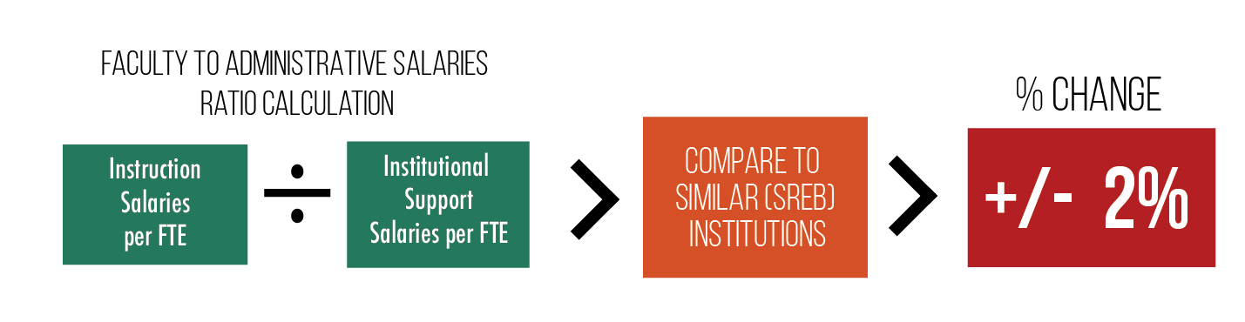
The baseline group that the institutional Faculty to Administrative Salary ratio will be compared to is the institution’s SREB peer group. The SREB peer group will be defined as all SREB institutions outside of the state of Arkansas who are in the same Carnegie Classification as the institution. A three-year Faculty to Administrative Salary Ratio Average will be calculated for the SREB peer group in the same way that it was calculated for the institution.
The adjustment for each institution is calculated by finding the percentage deviation of the Faculty to Administrative Salary Ratio of each institution compared to the SREB Average Faculty to Administrative Salary Ratio for their peer group. The resulting percentage is assigned an effectiveness adjustment as described in the chart below.

Points of Clarification:
- This metric is 50% of the Efficiency Category. The Efficiency Category can influence an institution’s score by no more than +/- 2%.

- A list of institutions included in the SREB peer group will be provided to each institution.

Funding Model Scaling
Simplified Definition:
Scaling is a mathematical formula applied to each metric’s raw score for the purpose of equalizing the score ranges.
Expanded Definition:
Each broad metric area (credentials, progression, etc.) results in a raw score based upon a “points” system derived for that metric. The total points that result from one metric can be either much larger or much smaller than the total points generated by another metric.

For example, 4-year universities may generate 100,000 points in the “credentials” metric, but only 1,000 points in the “transfers” metric. If these points were simply added together for a total of 101,000 points then credentials would make up (100,000 / 101,000) or 99% of the model and transfers would only make up (1,000 / 101,000) or 1% of the model. This is not the desired result.

The funding model specifications detail what percentage of the overall formula each metric should supply. Therefore, all metrics must have equally scaled points before they can be weighted and combined. Because the “credentials” metric usually generates the most points, that metric is used as the standard scale. All other metrics have a multiplier “index” applied to that metric’s points so that the total score for the metric for all universities (or all colleges) is equal to the total score for the credentials metric.

Specific Metric Criteria:
Data Year 2 of the Productivity Funding Formula for 4-Year Universities is provided below as an example of how scaling works.

Step 1: Using the Baseline Years data, for each institution type (4-Year and 2-Year) total the raw scores of each metric.

Step 2: Using the Credentials metric as base, divide each of the other metric raw score totals into credentials, to determine the scaling index. Using the example of Year 2 data, the Progression raw score of 94,479 is divided into the Credentials raw score of 183,380 which gives the scaling index for Progression of 1.94.

(1) UNSCALED  DATA |  | Effectiveness
 |  | Credentials | Progression | Gateway Success | Transfer Success
ASUJ | Score | 30882 | 11846 | 5325 | 368
ATU | Score | 18752 | 11596 | 6831 | 188
HSU | Score | 5661 | 3920 | 2386 | 102
SAUM | Score | 7250 | 3977 | 2451 | 65
UAF | Score | 54779 | 25877 | 12453 | 398
UAFS | Score | 9874 | 8025 | 5160 | 36
UALR | Score | 25733 | 9607 | 4228 | 310
UAM | Score | 5796 | 4021 | 2088 | 24
UAPB | Score | 5792 | 3816 | 2294 | 38
UCA | Score | 18859 | 11792 | 6657 | 204
4YR | Sum | 183380 | 94479 | 49874 | 1733
4YR | Index | 1.00 | 1.94 | 3.68 | 105.82

Step 3: Multiply the raw score for each institution by the index score for that metric. In this example, HSU’s raw Progression score of 3,920 is multiplied by 1.94 to give a scaled score of 7,609 for Progression.
(2) SCALED  DATA |  | Effectiveness
 |  | Credentials | Progression | Gateway Success | Transfer Success
ASUJ | Score | 30882 | 22993 | 19578 | 38905
ATU | Score | 18752 | 22507 | 25118 | 19858
HSU | Score | 5661 | 7609 | 8774 | 10829
SAUM | Score | 7250 | 7720 | 9011 | 6913
UAF | Score | 54779 | 50227 | 45789 | 42115
UAFS | Score | 9874 | 15577 | 18974 | 3845
UALR | Score | 25733 | 18647 | 15547 | 32768
UAM | Score | 5796 | 7804 | 7677 | 2575
UAPB | Score | 5792 | 7408 | 8435 | 3986
UCA | Score | 18859 | 22888 | 24478 | 21587
4YR | Sum | 183380 | 183380 | 183380 | 183380

Step 4: Multiply the model weightings for each metric against the Scaled score for each institution to calculate the weighted and scaled score.

(3) WEIGHTS |  | Effectiveness
 |  | Credentials | Progression | Gateway Success | Transfer Success | Effectiveness Index
Category Weights |  | 40% | 30% | 15% | 15% | 80%
Model Weights |  | 32% | 24% | 12% | 12%
(4) WEIGHTED & SCALED DATA |  | Effectiveness
 |  | Credentials | Progression | Gateway Success | Transfer Success | Effectiveness Index
ASUJ | Score | 9882 | 5518 | 2349 | 4669 | 22419
ATU | Score | 6001 | 5402 | 3014 | 2383 | 16800
HSU | Score | 1811 | 1826 | 1053 | 1299 | 5990
SAUM | Score | 2320 | 1853 | 1081 | 830 | 6084
UAF | Score | 17529 | 12054 | 5495 | 5054 | 40132
UAFS | Score | 3160 | 3738 | 2277 | 461 | 9636
UALR | Score | 8235 | 4475 | 1866 | 3932 | 18508
UAM | Score | 1855 | 1873 | 921 | 309 | 4958
UAPB | Score | 1854 | 1778 | 1012 | 478 | 5122
UCA | Score | 6035 | 5493 | 2937 | 2590 | 17056
4YR | Sum | 58682 | 44011 | 22006 | 22006 | 146704
4YR | Index | 32% | 24% | 12% | 12% | 80%

Step 4: Apply Diseconomies of Scale/Research Adjustments and Efficiency Adjustments to the weighted and scaled data to determine the Baseline total score.

Step 5: Using the same Index calculated for the Baseline years, follow the same steps in the Comparative years.

Step 6: Compare each institution’s Baseline to Comparative totals to determine the Productivity Index.

Step 7: This ends the calculation of the Productivity Funding Model. The Productivity Index for each institution is then applied to the Productivity Funding Distribution according to that policy.

Points of Clarification:
- The scaling index is not recalculated for the Comparative years. For consistency the Baseline scaling index is used for both data sets.

FAQs
Q1. Are concurrent/high school students included in this model?
A1. Concurrent/high school students are included in the credentials and progression metrics for all institutions and the gateway metric for the 2-year colleges.

Q2. How will the new placement policy impact this formula?
A2. The definition of underserved academic is based upon a student who enrolls in a remedial English, math, or reading course. It does not look at the placement test score or the placement test field in the student table. A remedial level course is determined by looking at courses where Course_Level = 0 in the Credit Course File Table.

Q3. We are attempting to pull data internally to look at how we are doing, but our numbers are not matching ADHE’s reported numbers. Why can’t I get them to match?
A3. It is important to understand that some metrics utilize data at the state level that individual institutions do not have access to. Transfer data, total credit hours taken at all in-state public institutions, and Pell eligibility at multiple campuses, are a few examples of data that may cause internal estimates to differ from numbers produced by ADHE.

Q4. When am I compared to myself vs to other institutions?
A4. In the Effectiveness and Affordability measures institutions are compared to themselves using a rolling three-year comparative average. For example, the baseline subset average of 2014, 2015 and 2016 will be compared to the comparative subset average of 2015, 2016 and 2017. The difference in the averages, either positive or negative, will be used in calculating the institution’s Productivity Index.
In the Adjustment measures a three-year average will be calculated but will not be measured against a three-year comparative. The Research category will use the three-year average to calculate percentage of expenditures used on research at that institution. This is not a comparison at all, simply a calculation. The Diseconomies of Scale category will compare the three-year average headcount to the three-year average headcount of 2-year colleges in Arkansas (not including UAPTC or NWACC).
In the Efficiency measures a three-year average will be calculated but will not be measured against a three-year comparative. In these categories, the three-year average will be compared against the three-year average of SREB institutions in that institution’s peer group.

Q5. Does this formula use the IPEDS definition of a cohort?
A5. As a whole, this formula does not use the IPEDS definition of a cohort (First-Time, Full-Time, Degree Seeking in the Fall Semester). Each category defines its cohort differently based upon what is being measured so that it can more accurately represent the populations served by institutions. The only category that uses the IPEDS definition of a cohort is the Time-to-Degree category. Please see each category definition for the details of what makes up each cohort.

Q6. We have a large population of part-time students. Won’t this unfairly hurt us in the Progression and Time-to-Degree categories?
A6. No. It is important to remember in the Effectiveness and Affordability metrics, that you will only be compared to yourself. This is not like the old formula where an institution has to get a set number of points to be successful. If in the past, only 30 out of 100 graduating students completed their degrees “on-time” because of the high population of part-time students, that is what you will be compared to. In this scenario, 31 out of 100 graduating students completing “on-time” will be considered positive change. This model does not intend to change the mission of an institution.

Productivity Funding Model
Contact Information

For questions regarding the Productivity metric definitions, related AHEIS data submissions, and the Specifications document, please contact:
Beth Stewart
Senior Policy Analyst
Tel: 501.371.2058
beth.stewart@adhe.edu

For calculation of funding distribution questions, contact:
Nick Fuller
Assistant Director of Finance
Tel: 501.371.2026
nick.fuller@adhe.edu

